**8-BIT DIVISION**  
**EXP NO: 4**  
**AIM:**To write an assembly language program to implement 8-bit division using 8085 processor.  
**ALGORITHM:**  
1)      Start the program by loading a register pair with the address of memory location.  
2)      Move the data to a register.  
3)      Get the second data and load it into the accumulator.  
4)      Subtract the two register contents.  
5)      Increment the value of the carry.  
6)      Check whether the repeated subtraction is over.  
7)      Store the value of quotient and the reminder in the memory location.  
8)      Halt.  
**PROGRAM:**  
         LDA 8501  
        MOV B, A  
        LDA 8500  
        MVI C,00  
LOOP:   CMP B  
        JC LOOP1  
        SUB B  
        INR C  
        JMP LOOP    
LOOP1:  STA 8502  
        MOV A, C  
        STA 8503  
        RST 1  
**INPUT:**

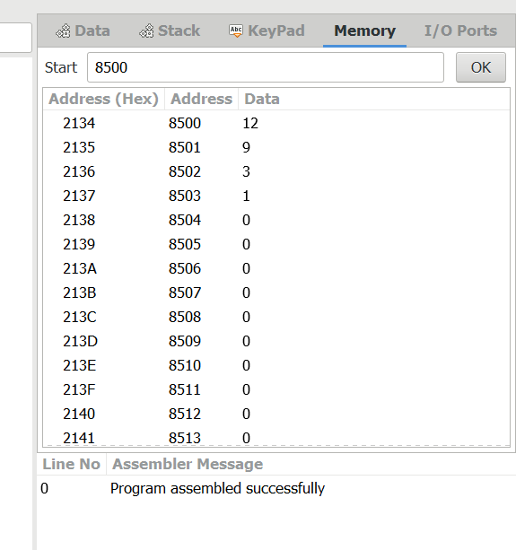

**OUTPUT:**

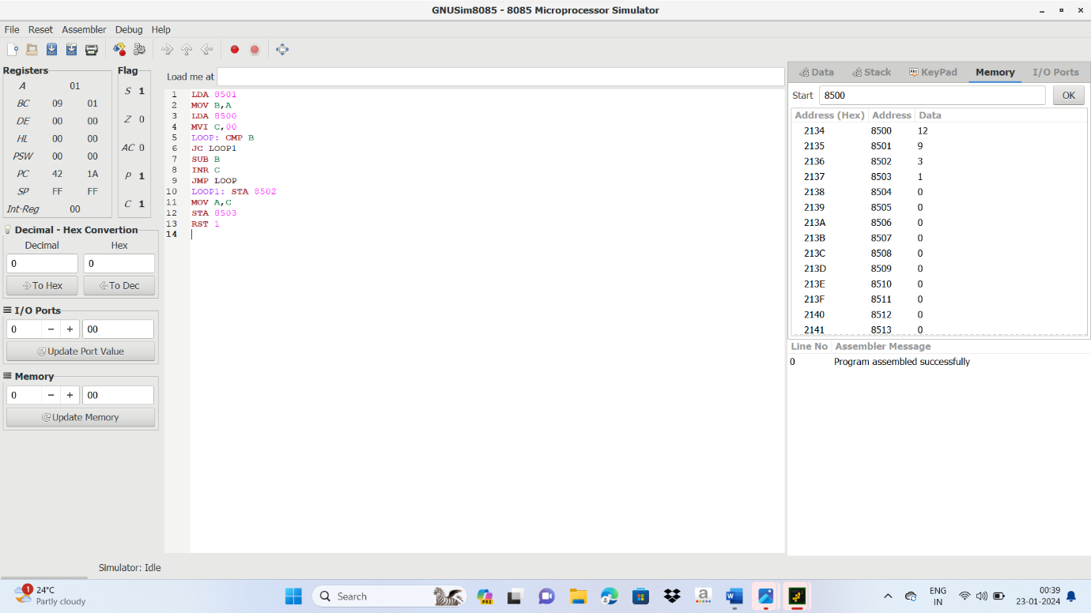

**RESULT:**

**Thus the program was executed successfully using 8085 processor simulator.**